IoT

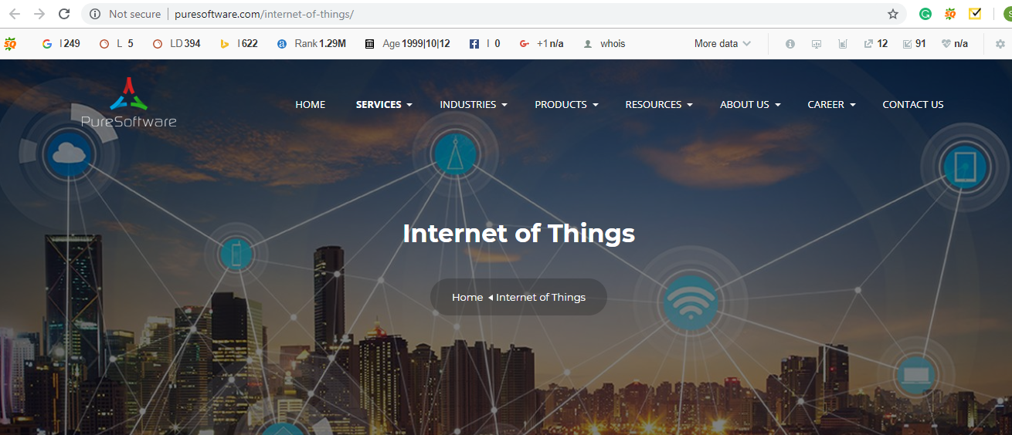

Text to be used on the image

***The Internet of Things (IoT) is emerging as the next technology mega-trend, with powerful and remarkable effects across the business spectrum. Gartner predicts that there will be over $25 Billion connected “things” by 2020.***

Next>>

IoT connects to the Internet, billions of everyday devices, which ranges from small gadgets to the mechanical gear. IoT blends the physical and online universes and opens up a large group of new chances and difficulties for endeavors, organizations, governments, and customers.

A ton of things will change – personal lives, efficiency at work environment and the utilization design. The Internet of Things is anticipated to pervade relatively every sphere and industry. Information can be gathered from, for all intents and purposes, any possible source. IoT is advancing and Cloud is the stage of decision for the combination of information from machines and IT systems.

The Internet of Things has bounty to offer organizations, however the conceivable outcomes are just barely starting. At Nunc Systems, we try to apply this progressive innovation in the most gainful path for the present day, and keeping in mind that watching out for what's to come.

* IoT allows for complete integration of individuals, applications, and gadgets.
* All parts of the system can speak to each other.
* This is performed by means of an Internet connection

**Next>>**

[**https://www.applexus.com/services/iot**](https://www.applexus.com/services/iot)

**Our Approach**

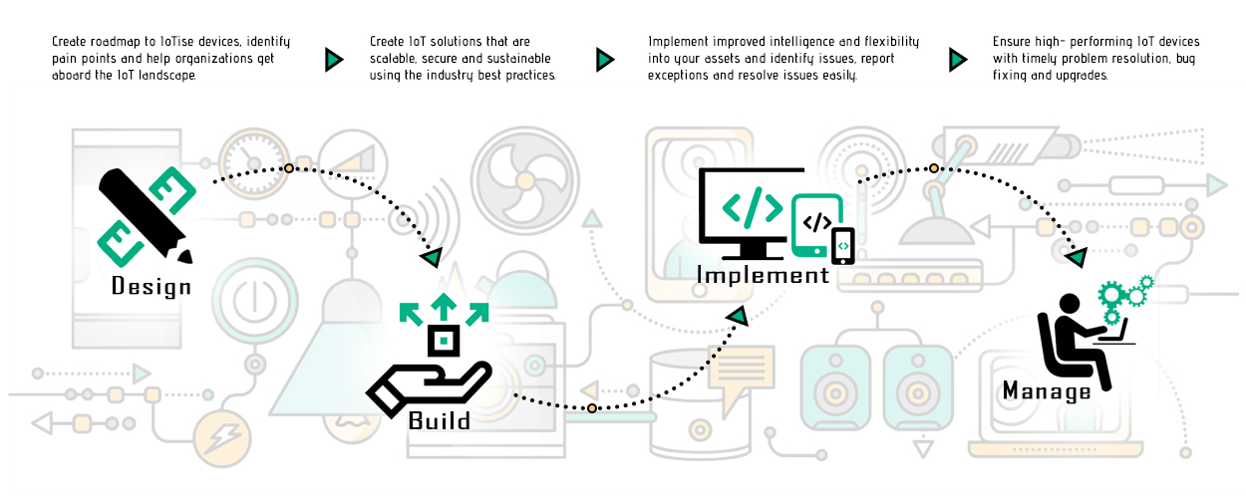

**How our IoT Arrangements Can Enable and Enhance Organizations**

**Operations**

We can configure IoT to enhance your tasks, permitting deferred timescales to become a thing of the past. Each procedure is dealt with easy correspondence, issues are fixed and settled in record time, and consumer loyalty is expanded because of the streamlining of the request and delivery process.

**Low Cost**

Our IoT solutions enable you to screen your business costs —, for example, service bills — so you can identify areas in which you can save money. Smart technology permits you greater control over expenditure and can identify areas you may be able to make savings.

**Enhanced Inter-business Communications**

Enable divisions to communicate with each other effectively, maintaining a strategic distance from potential expensive delays and reducing the need for tedious human discussion. Our usage of IoT standards takes into account a basic, information-driven methodology that centers consideration where it is required

**Reliable Monitoring**

Our IoT systems are intended to monitor themselves, authorizing HR for other projects. At the point when a fault is identified, not only is it found quickly, but the system can be able to repair itself instead of requesting human consideration.

Benefits of IoT

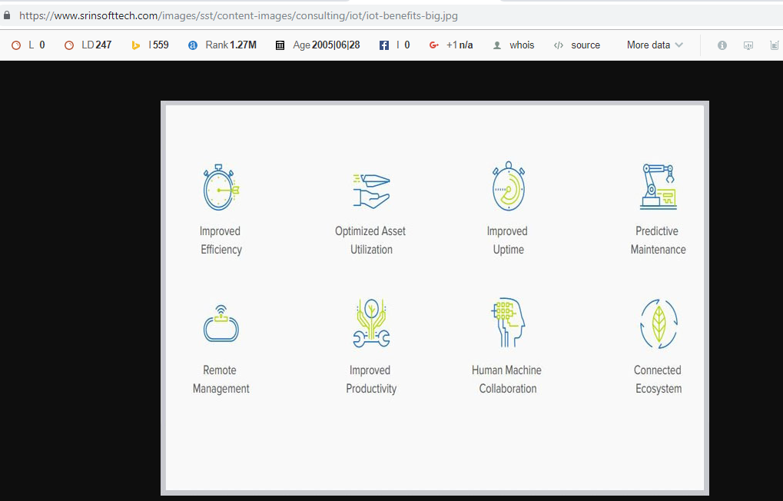

Next>>

**Request a Quote**

